:росток:Beet Seed

**BR#1**

Text overflows off the screen in “Виберіть місто” menu at 100% page zoom.

Browser: Google Chrome 131.0.6778.205 (Official Build) (64-bit); Microsoft Edge 131.0.2903.112 (Official build) (64-bit); Firefox 134.0 (64-bit).

OS: Windows 11

Preconditions:

1. Main page is open: <https://oxford-med.com.ua/ua/>
2. Page zoom set to 100%.

STR:

1. Click on the “Виберіть місто” button.
2. Observe the result.

Expected result: All text remains fully visible and within the page layout at 100% zoom.

Actual result: Some text elements overflow off the top and bottom of the screen and are not visible, requiring page zoom adjustment to read

Priority: High (проблема виникає при масштабі 100%, що є дефолтним для більшості користувачів)  
Severity: Minor

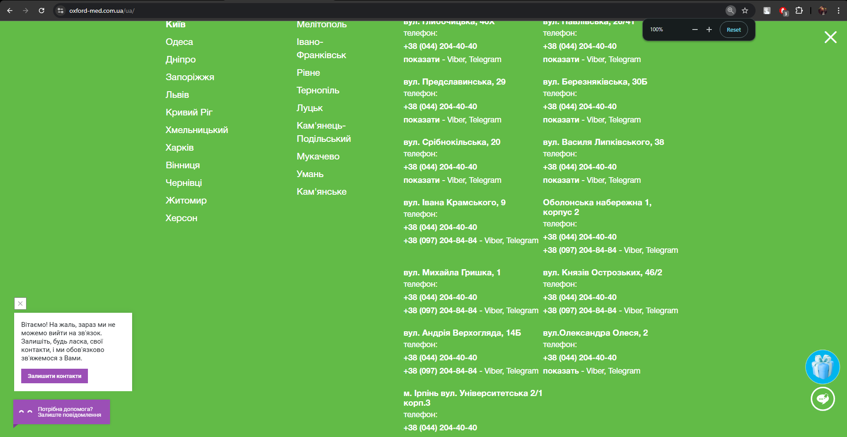

**BR#2**

Cursor does not change to a pointer when hovering over a “показати” button on the

“Виберіть місто” menu.

Browser: Google Chrome 131.0.6778.205 (Official Build) (64-bit); Microsoft Edge 131.0.2903.112 (Official build) (64-bit); Firefox 134.0 (64-bit).

OS: Windows 11

Preconditions:

1. Main page is open: <https://oxford-med.com.ua/ua/>

STR:

1. Click on the “Виберіть місто” button.
2. Hover the cursor over a “показати” button.

Expected result: The cursor changes to a pointer to indicate the button is clickable.

Actual result: The cursor changes to an I-beam, not providing correct feedback.

Priority: Low   
Severity: Minor

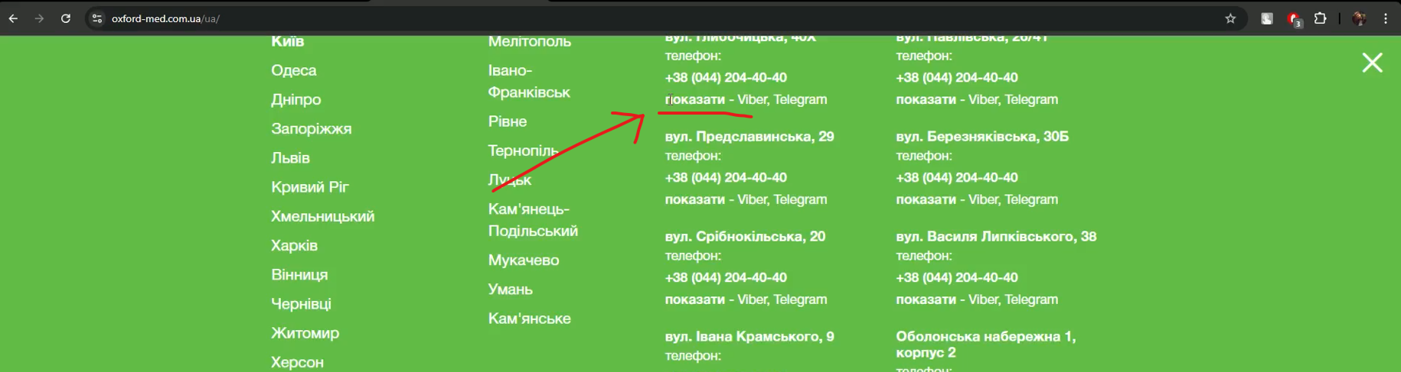

**BR#3**

Horizontal scrolling is present on “Reviews” section in the “Всі відгуки про клініку” dropdown menu.

Browser: Google Chrome 131.0.6778.205 (Official Build) (64-bit); Microsoft Edge 131.0.2903.112 (Official build) (64-bit); Firefox 134.0 (64-bit).

OS: Windows 11

Preconditions:

1. Main page is open: <https://oxford-med.com.ua/ua/>

STR:

1. Navigate to the “Reviews” section.
2. Click on “Всі відгуки про клініку” dropdown list.

Expected result: The dropdown menu content should be fully visible without the need for horizontal scrolling.

Actual Result: A horizontal scrollbar appears.

Priority: Low  
Severity: Minor

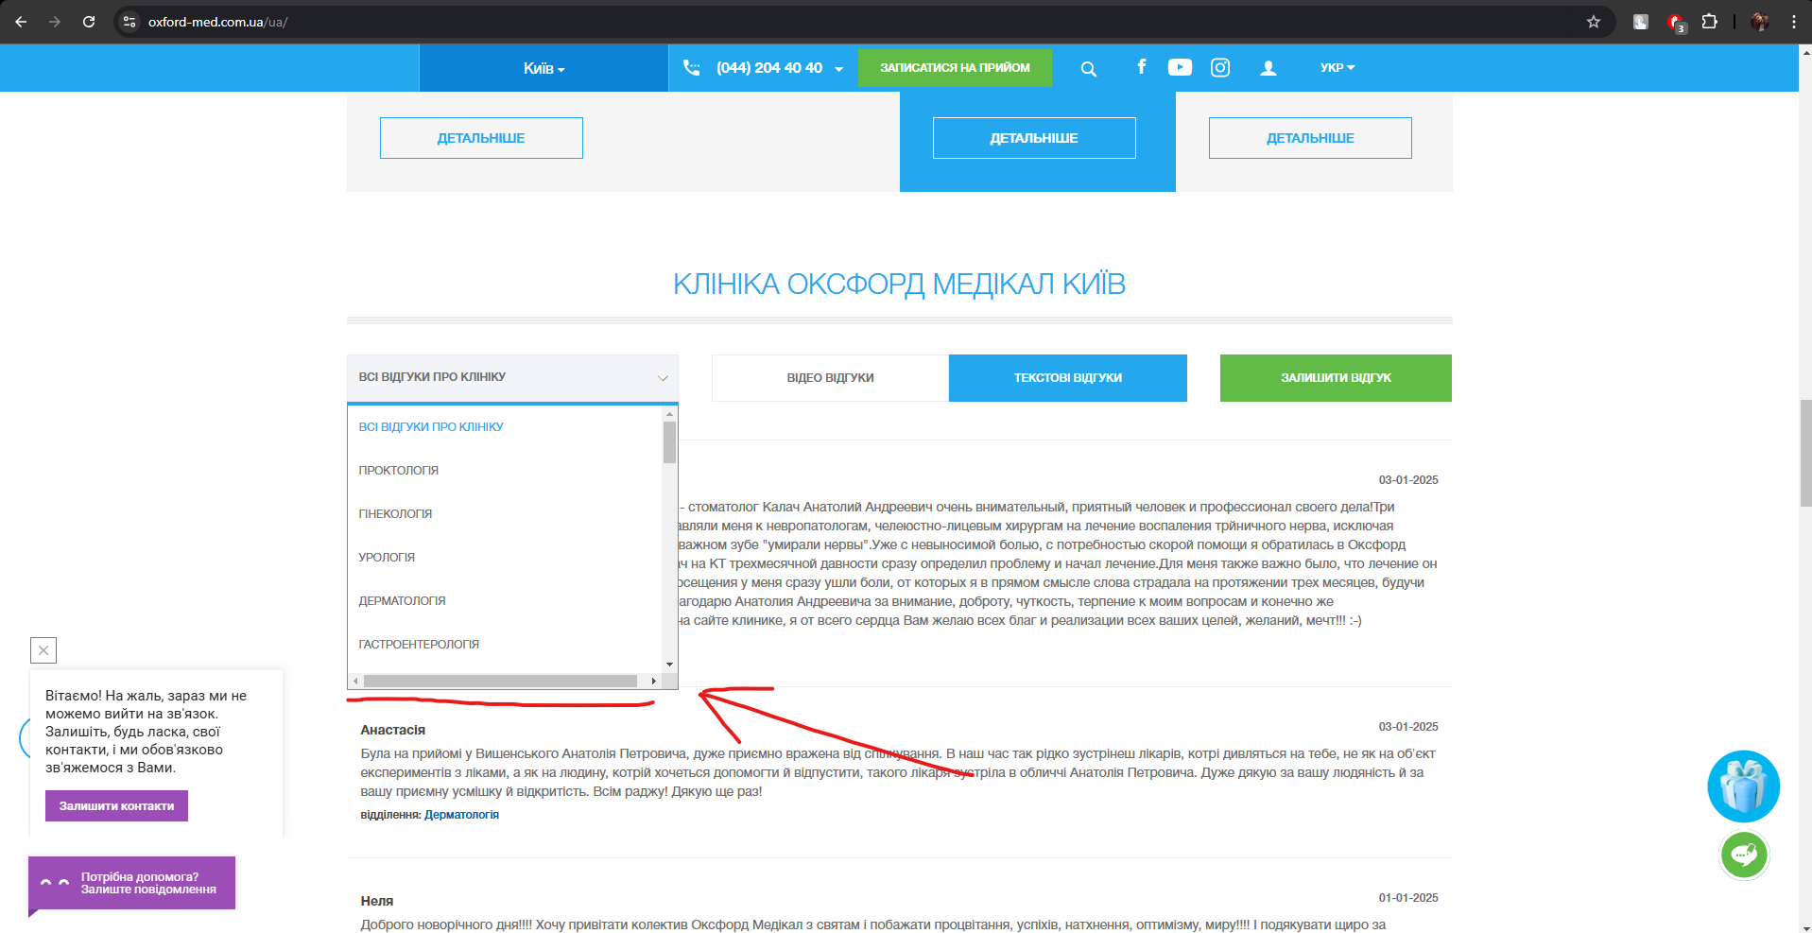

**BR#4**

The content isn't aligned to the center in the page body on the “Reviews” page.

Browser: Google Chrome 131.0.6778.205 (Official Build) (64-bit); Microsoft Edge 131.0.2903.112 (Official build) (64-bit); Firefox 134.0 (64-bit).

OS: Windows 11

Preconditions:

1. Main page is open: <https://oxford-med.com.ua/ua/>

STR:

1. Navigate to the “Reviews: page. <https://oxford-med.com.ua/ua/reviews/>
2. Observe the alignment of the content in the page body.

Expected result: The content should be centered within the page body.

Actual result: The content is not centered and appears misaligned.

Priority: Medium  
Severity: Minor

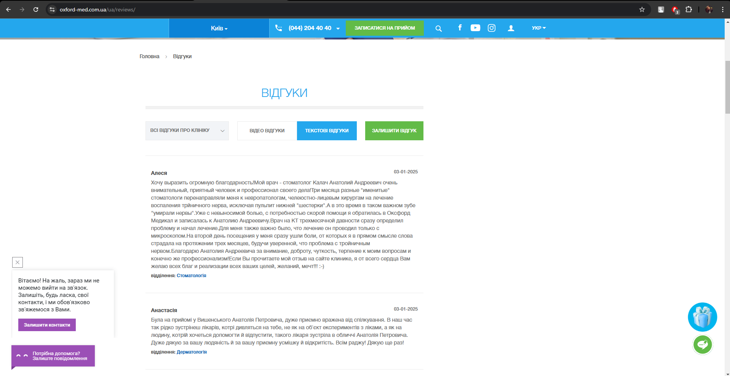

.

**BR#5**

The “Discounts” banner isn't centered on the main page in the page header.

Browser: Google Chrome 131.0.6778.205 (Official Build) (64-bit); Microsoft Edge 131.0.2903.112 (Official build) (64-bit); Firefox 134.0 (64-bit).

OS: Windows 11

Preconditions:

1. Main page is open: <https://oxford-med.com.ua/ua/>

STR:

1. Observe the “Discounts” banner alignment on the page header.

Expected result: The content is centered.

Actual result: The content is not centered and appears misaligned.

Priority: High (проблема на головній сторінці сайту, що негативно впливає на загальний вигляд сайту)  
Severity: Minor

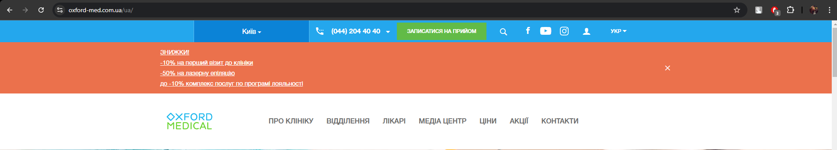

**:лиственное_дерево:**Mighty Beet

1. Номер телефону у хедері - 16px / 24px HelveticaNeue-Bold, sans-serif; бекграунд - #24a7ed, текст - #fff
2. Ім’я асистента при виклику чата допомоги - Roboto,sans-serif; бекграунд - #9B4FB6, текст - #fff
3. Кнопка “інші міста” у футері сайту - 14px / 24px HelveticaNeue, sans-serif; бекграунд - #ebebeb,текст - #24a7ed
4. Placeholder “ім’я” у формі “ЗАПИСАТИСЯ НА ПРИЙОМ” - 14px / 14px HelveticaNeue, sans-serif; бекграунд - #fff, текст - #535353